# IBM ASSIGNMENT 1

Name: Shahul Hameed. S

Reg No: 1919103107

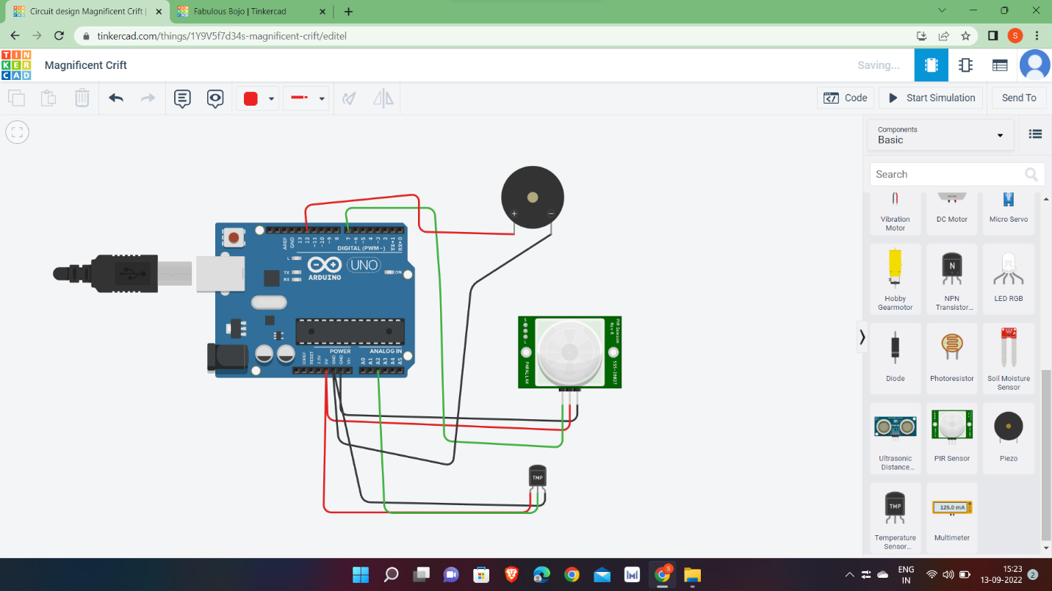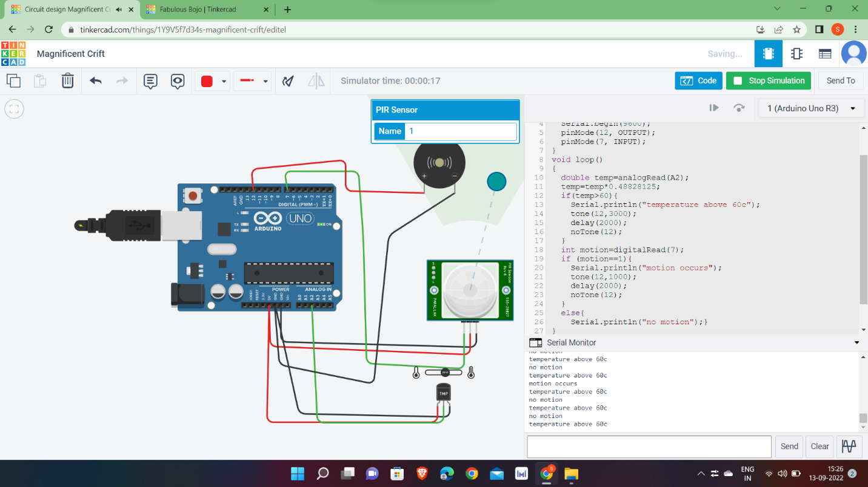

# CODING :

void setup()

{

Serial.begin(9600);

pinMode(12, OUTPUT);

pinMode(7, INPUT);

}

void loop()

{

double temp=analogRead(A2);

temp=(temp/1024.0)*5000;

temp=temp/10;

if(temp>60){

Serial.println("temperature above60c");

tone(12,3000);

delay(2000);

noTone(12);

}

int motion=digitalRead(7);

if (motion==1){

tone(12,1000);

delay(2000);

noTone(12);

}

else{

Serial.println("no motion");

}

}